INTERNATIONAL CYBERSECURITY AND DIGITAL FORENSICS ACADEMY (ICDFA)

Digital Forensics Lab 1 - Case Handling, Autopsy and Sleuth Kit Analysis

Lab Title: | Autopsy and Sleuth Kit Analysis
Student Name: | Yusuf Oluwaseun Dada
Student ID: | 2025/FWSD/11339
Course Code: | SBT-DF202
Course Name: | Computer and Digital Forensics

Instructor: Mr. Aminu Idris {The Founder}

Date: 29/08/2026

Objectives

Actionable plans
By completing this lab, trainees will demonstrate their ability to apply the digital forensic investigation process in a controlled practical environment. Students will preserve and hash a forensic disk image, perform structured analysis using Autopsy, examine the image using The Sleuth Kit command-line tools, identify and recover deleted files, analyse file metadata and data units, perform keyword searches, verify recovered evidence using cryptographic hashes, and prepare a professional forensic report containing repeatable findings.
Students are expected to demonstrate practical competence with tools and commands including Autopsy, img_stat, mmls, fsstat, fls, istat, icat, blkcat, blkls, tsk_recover, md5sum and sha256sum.

Scenario

As a junior digital forensic analyst in the ICDFA laboratory. I have been provided with a forensic disk image named Ch01InChap01.dd. The requesting officer requires you to identify deleted files, recover relevant office documents, perform keyword searches, preserve your analysis steps, verify evidence integrity, and prepare a repeatable technical forensic report. The original evidence image must not be modified during the investigation.

Procedure

Laboratory instructions

Purpose: covering digital investigation procedures, evidence handling, chain of custody, forensic imaging, Autopsy and The Sleuth Kit.
Download the authorised training forensic image Ch01InChap01.dd and create a dedicated forensic working directory before beginning your analysis. If the direct download does not start automatically, use the browser download page instead. The source lab specifically provides this evidence image for the practical.
After downloading the evidence image, record the evidence source, file size, storage location, MD5 hash and SHA-256 hash before conducting any forensic analysis. Preserve the original image and perform recovery and examination activities in separate working folders.

Environment & Tools
On Kali Linux VM. Sleuth Kit and Autopsy both run natively on Kali
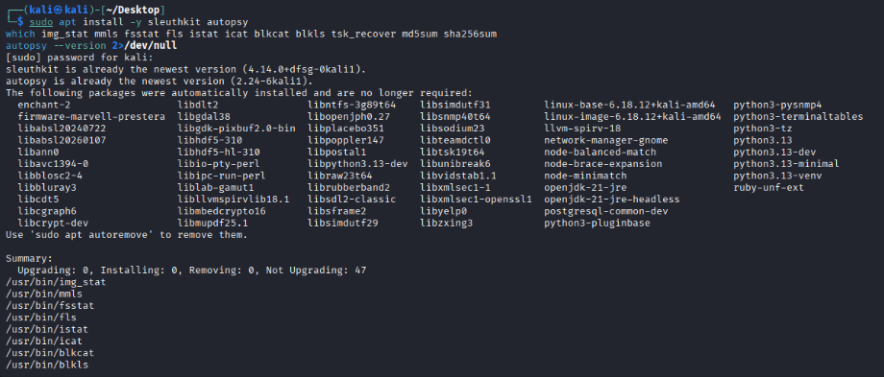

sudo apt update
sudo apt install -y sleuthkit autopsy
which img_stat mmls fsstat fls istat icat blkcat blkls tsk_recover md5sum sha256sum
autopsy --version 2>/dev/null

Dedicated Lab Folder Structure
I kept the original image, working/analysis copies, and my recovered evidence in separate folders
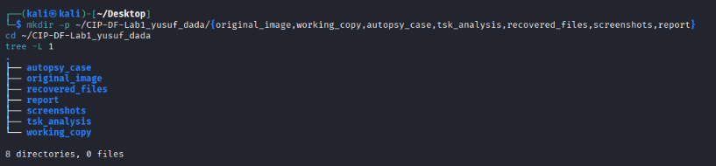
mkdir -p ~/CIP-DF-Lab1_yusuf_dada/{original_image,working_copy,autopsy_case,tsk_analysis,recovered_files,screenshots,report}
cd ~/CIP-DF-Lab1_yusuf_dada
tree -L 1

Evidence Image
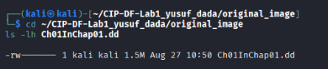
After I downloaded the Ch01InChap01.dd using the link/download page provided on course portal and save it into original_image/.
cd ~/CIP-DF-Lab1_yusuf_dada/original_image
ls -lh Ch01InChap01.dd

Hash the original BEFORE any analysis
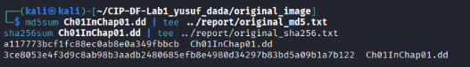
md5sum Ch01InChap01.dd | tee ../report/original_md5.txt
sha256sum Ch01InChap01.dd | tee ../report/original_sha256.txt

I make a working copy, all analysis to happen on the copy, and not the original:
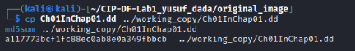
cp Ch01InChap01.dd ../working_copy/Ch01InChap01.dd
md5sum ../working_copy/Ch01InChap01.dd

Mini Chain-of-Custody
Field | Value
Evidence item | Ch01InChap01.dd
Obtained from | Course portal (campus.icdfa.edu.ng)
Date/time acquired | 27/08/2026 10;50pm
Examiner | Yusuf Oluwaseun Dada
Original file size | 1.5m
Original MD5 | a117773bcf1fc88ec0ab8e0a349fbbcb
Original SHA-256 | 3ce8053e4f3d9c8ab98b3aadb2480685efb8e4980d34297b83bd5a09b1a7b122
Working copy location | ~/CIP-DF-Lab1_yusuf_dada/working_copy/
Working copy hash verified | Yes, matches original

Part A - Autopsy Analysis (GUI)

A1. Launch Autopsy and create a case
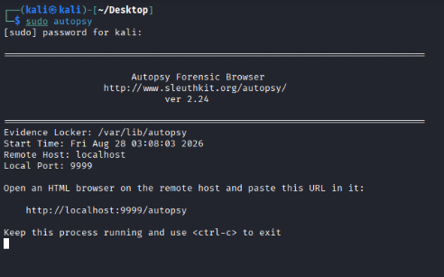

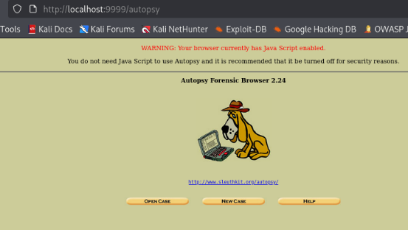

/home/kali/CIP-DF-Lab1_yusuf_dada/Ch01InChap01.dd

autopsy
I starts a local web server - Autopsy to print a URL (http://localhost:9999/autopsy); in my firefox browser.
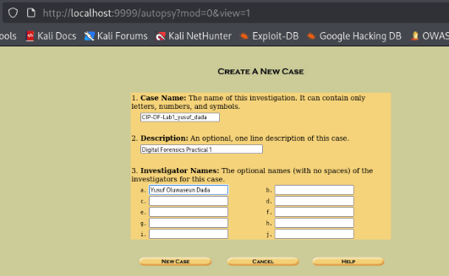
Steps:
- New Case
- Case Name: InChap01 (or CIP-DF-Lab1_yusuf_dada)
- Description: brief note, e.g. “Digital Forensics Lab 1 practical - yusuf dada”
- Examiner: my name
- Click New Case to finish

A2. Add the evidence source
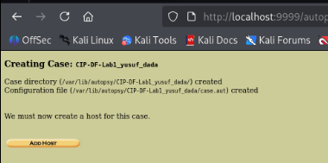

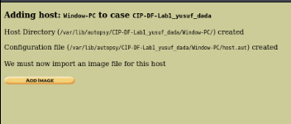

Steps:
- Add Data Source
- Data source type: Disk Image
- Browse to working_copy/Ch01InChap01.dd I don’t point Autopsy at the original file in original_image/
- Default Ingest Module settings, Next, then Finish.

A3. Identify deleted files
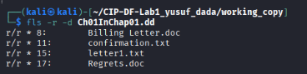

A4. Recover relevant files
Right-click INCOME.XLS (or whichever deleted file(s) you find) → Extract File(s) → save into recovered_files/.

A5. Keyword search
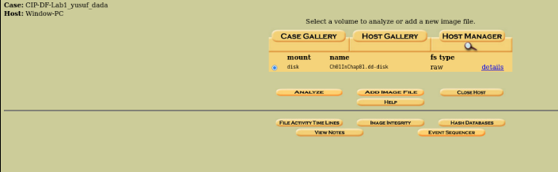
Usage of Autopsy’s built-in keyword search (usually a search box or “Keyword Search” tab) to search for a relevant term, e.g. income or xls.

A6. Tag relevant evidence
Right-click the recovered/relevant file >> Tag File >> choose or create a tag like “Relevant Evidence.”

A7. Generate the Autopsy report
Menu: Tools >> Generate Report (or a Report button in the toolbar) >> choose a report format (HTML is easiest to screenshot) >> generate.

Part B - Sleuth Kit Command-Line Analysis

B1. Image details
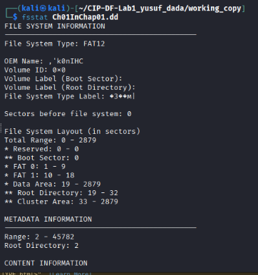
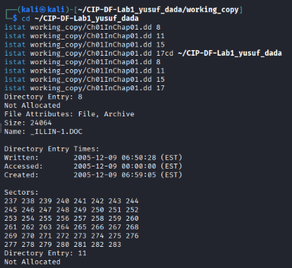
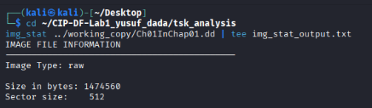
cd ~/CIP-DF-Lab1_yusuf_dada/tsk_analysis
img_stat ../working_copy/Ch01InChap01.dd | tee img_stat_output.txt

B2. Partition/volume layout
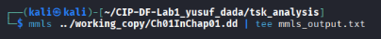
mmls ../working_copy/Ch01InChap01.dd | tee mmls_output.txt
This is the critical step to note the “Start” sector number of the partition/volume that contains the file system

B3. File system details
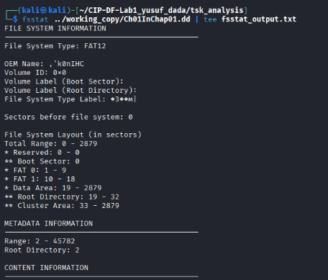
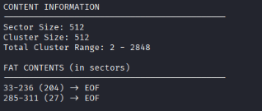
fsstat ../working_copy/Ch01InChap01.dd | tee fsstat_output.txt
This shows file system type, cluster size, and volume details.

B4. List files, including deleted ones
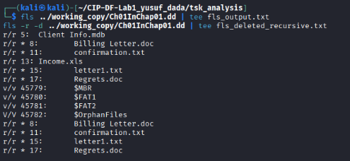
fls ../working_copy/Ch01InChap01.dd | tee fls_output.txt
fls -r -d ../working_copy/Ch01InChap01.dd | tee fls_deleted_recursive.txt
-d shows only deleted entries, -r makes it recursive through subdirectories. Deleted entries are typically marked with a * before the filename.
The recursive deleted-file listing, with INCOME.XLS visible

B5. Find INCOME.XLS’s metadata address

The number before the colon (here, 15) is the inode/metadata address.
INCOME.XLS and its metadata address

B6. Examine its metadata in detail
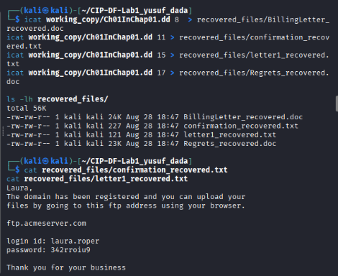
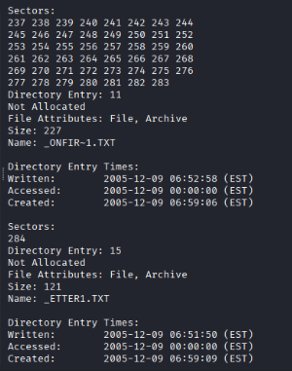
istat ../working_copy/Ch01InChap01.dd <INODE_NUMBER> | tee istat_income_xls.txt
This shows file size, timestamps (MAC times), and the specific data unit/block/cluster addresses the file occupies, record the file size and block numbers
istat output for INCOME.XLS

B7. Recover the file using icat
icat ../working_copy/Ch01InChap01.dd <INODE_NUMBER> > ../recovered_files/INCOME_recovered_icat.xls
ls -lh ../recovered_files/INCOME_recovered_icat.xls

B8. Recover using blkcat (raw block/cluster-level recovery)
Using the block numbers:
blkcat ../working_copy/Ch01InChap01.dd <BLOCK_NUMBER> > ../recovered_files/INCOME_recovered_blkcat_block1.dat
If the file spans multiple blocks/clusters (likely, since spreadsheets are usually bigger than one cluster), repeat for each block number from istat and concatenate them in order, or use blkcat’s range syntax if your version supports blkcat -o <offset> image <start>-<end>.
blkcat recovery attempt and output

B9. Additional recovery using tsk_recover
tsk_recover ../working_copy/Ch01InChap01.dd ../recovered_files/tsk_recover_output/
ls -la ../recovered_files/tsk_recover_output/
tsk_recover automatically walks the file system and recovers files (by default, allocated files,and to add -e to include deleted/unallocated files too):
tsk_recover -e ../working_copy/Ch01InChap01.dd ../recovered_files/tsk_recover_deleted/

B10. Compare hashes of all recovered copies
cd ~/CIP-DF-Lab1_yusuf_dada/recovered_files
md5sum INCOME_recovered_icat.xls
md5sum tsk_recover_deleted/*/INCOME.XLS 2>/dev/null
sha256sum INCOME_recovered_icat.xls

B11. Confirm the recovered spreadsheet actually opens
libreoffice --calc ../recovered_files/INCOME_recovered_icat.xls
Or use file to confirm it’s a valid spreadsheet before opening:
file ../recovered_files/INCOME_recovered_icat.xls
File successfully opened in LibreOffice Calc (or another spreadsheet tool), showing readable spreadsheet content.

